The following chapters outline 17 common modern techniques used to target Active Directory FICAM domains and network environments. They will explain how threat actors use each technique and provide recommended mitigation strategies. By applying these recommendations, defenders can strengthen Active Directory FICAM security and improve overall network resilience against malicious intrusion.
Microsoft Active Directory is the world’s most widely used authentication and authorization platform for enterprise IT networks. It includes services such as Active Directory Domain Services (AD DS), Active Directory Federation Services (AD FS), and Active Directory Certificate Services (AD CS). Together, these services support multiple authentication methods, including PKI smart card logon with Common Access Cards (CACs) and Single Sign-On (SSO) for on-premises and cloud-based directory services provided by Microsoft.
Because Active Directory is central to authentication and authorization, it is a high-value target for threat actors. Attackers routinely target it in enterprise environments, and it is especially vulnerable due to permissive default settings, complex trust relationships across domains and forests, misconfigurations, legacy protocol support, limited security diagnostics, and gaps in administrative security awareness. Threat actors commonly exploit these very weaknesses to compromise Active Directory FICAM domains and network environments.
Active Directory is also susceptible to compromise because, by design, all users have enough access to discover and potentially exploit weaknesses themselves. This creates a broad attack surface that is difficult to defend on the daily. Its risk is further increased by the very complexity and sore lack of visibility in to the relationships among users, systems, and permissions. Threat actors often take advantage of these overlooked connections – whether intentionally, or not – and more times than not, done through relatively simple methods that all have one main common goal in mind: to gain full control of an organization’s enterprise domain.
Compromise of Active Directory provides adversaries with effective control over the identity, authentication, and authorization fabric for the systems, users, and services managed by the directory services. At that point, an adversary can leverage privileged access to circumvent or undermine existing security controls and obtain broad access to enterprise resources, including messaging platforms, file services, and mission-critical business applications. In hybrid environments, this access frequently extends into cloud resources through federated or synchronized identity integrations with Microsoft Entra ID. Although these integrations are intended to enable legitimate access to cloud-based services, they can also be abused by adversaries to expand their operational reach, increase dwell time, and maintain persistent access across on-premises and cloud environments. As a result, control of Active Directory can support a wide range of adversarial objectives, from financially motivated intrusion activity to long-term state-sponsored espionage within a victim enterprise.
Adversaries can also abuse Active Directory to establish durable persistence within susceptible enterprise environments. Certain persistence mechanisms enable remote re-entry and continued authentication even in environments protected by Multi-Factor Authentication (MFA) and depending on the identity path or trust mechanism that has been compromised. Many of these techniques are resilient to standard incident response and remediation measures and may survive containment actions intended to disrupt and evict the threat actor. In mature compromises, sophisticated adversaries may remain embedded in Active Directory for months or even years before detection or full eradication. Removal of a deeply rooted adversary can require high-impact recovery measures, including enterprise-wide credential resets, reissuance of trust and credentialed key material, or complete reconstruction of the Active Directory infrastructure from the ground up. Because response and recovery following Active Directory compromise are typically resource-intensive, costly, timely, emotionally draining, and operationally disruptive, organizations should implement the recommendations in this chapter to strengthen visibility, harden identity infrastructure, and reduce the risk of full domain compromise.
Detecting and Mitigating Active Directory Compromises
Understanding Active Directory Infrastructure
For defenders and attackers alike, Active Directory is a large and complex identity system composed of thousands of interconnected objects that are governed by permissions, configurations, trust relationships, and cross-domain dependencies. All of which are managed and administered by humans - systems administrators, security professionals, network engineers, and all in between. Naturally, we are prone to introducing error, whether originally intended, or not. Fact remains we, as a collective human species introduce error; therefore, a thorough understanding of object permissions and the relationships among these objects is essential to accurately knowing how to apply and manage security in any Active Directory environment you may be trying to protect, or attack, for that matter.
As a defender, it is quite necessary that you understand the threat actor attack chain before you can begin any defensive activity against your domain. First, understand that adversaries will first commonly enumerate Active Directory infrastructure to collect information about a target environment. Whether that be through footprinting, information gathering, reconnaissance (both passive and active), the end result is all the same: harvested information (and, publicly free information, at that) performed against an unsuspecting target entity.
This activity, however, often occurs after initial access and after a solid foothold has been obtained, although, in some attack chains, it may occur earlier, or even at a later point. Through domain and subdomain network enumeration, with the help of various tools that are utilized for malicious purposes by threat actors and also utilized for the good of security by security professionals, tools like BloodHound aid both attackers and defenders alike in mapping domain structures, identifying key objects, reviewing of AD configurations, and in analyzing trusts and complex access relationships that span many unique domains and forests (no two organizational domains or networks are hardly ever alike). In many cases, this process, if you think about it, gives attackers a more complete operational understanding of the environment that they are up against. Because, who goes into battle blind? That advantage is often driven by the attacker’s ability to devote substantial time and resources to reconnaissance without the same operational constraints faced by defenders. Adversaries are then able to use this knowledge to identify weaknesses and misconfigurations that support privilege escalation, lateral movement, and, ultimately, full domain compromise.
To improve resilience against these attacks, defenders must develop a comprehensive understanding of their own Active Directory architecture and configuration baselines. Numerous commercial and open-source tools can support this analysis, including the following:
- BloodHound: Provides a graphical interface for analyzing Active Directory relationships, identifying attack pathways, and exposing misconfigurations or privilege escalation opportunities.
- Netwrix PingCastle: Generates a detailed security assessment of an Active Directory environment and highlights key areas of elevated risk.
- Purple Knight: Evaluates Active Directory security posture and identifies common exposures and configuration weaknesses.
Active Directory Objects
Active Directory stores directory information as objects that represent resources such as users, computers, groups, and Organizational Units (OUs). In enterprise domains, the most prevalent object classes are user and computer objects. User objects represent security principals, including individual users, service accounts, and built-in accounts such as the Kerberos Ticket Granting Ticket (krbtgt) account. Computer objects, on the other hand, represent domain-joined systems, including servers and workstations. Each system joined to an Active Directory domain is associated with a corresponding computer object. Collectively, these objects comprise authentication, authorization, and the application and enforcement of security policy via Group Policy Objects (GPOs).
Detecting and Mitigating Active Directory Compromises
Numerous known and observed techniques have been used to compromise AD DS, AD CS, and AD FS. Adversaries target these services to escalate privileges and move laterally across enterprise networks. The following guidance addresses the most common compromise techniques affecting these Active Directory components, providing both a technical overview of each method and recommended mitigation strategies. The material is organized in the general sequence in which these techniques are typically executed, beginning with methods that are commonly used for privilege escalation and lateral movement and concluding with those that are designed to establish long-term domain persistence.
Note for Securing Privileged Access
The immediate objective of malicious activity involving Active Directory compromise is typically privilege escalation leading to domain control usually by targeting the most highly privileged security principals, such as members of the Domain Admins and Enterprise Admins groups. Although substantial access can also be obtained by compromising other privileged accounts, including service accounts, preventing adversaries from gaining access to the highest privilege principals is critical to limiting overall attacker capability. For this reason, securing privileged access is a foundational requirement for mitigating Active Directory compromise and should be treated as a top priority by defenders and organizations alike.

Privileged access in Active Directory can be more effectively secured through a tiered administrative model, such as Microsoft’s Enterprise Access

The following are some key principles of securing privileged domain access:

- Tier 0 user objects do not expose their credentials to lower tiered systems. Tier 0 user objects are any user object that has significant access in a domain (for example, those in the Domain Admins and Enterprise Admin security groups, KRBTGT user objects, and AD FS service accounts, backup administrators and Microsoft Entra Connect user objects).
- Tier 0 computer objects are only managed by Tier 0 user objects. Tier 0 computer objects include Domain Controllers (DCs), the AD FS server, the AD CS root certificate authority, backup servers, and the Microsoft Entra Connect server.
- User and computer objects in lower tiers (such as Tier 1 or Tier 2) can use services provided by higher tiers; however, the reverse is not permitted.
- Hierarchy is enforced to prevent control of higher tiers from lower tiers.
- Privileged access pathways are secured by minimizing the number of privileged access pathways, implementing security protections and mechanisms, and closely monitoring and logging for anomalous activities across those pathways.

Tier 0 user and computer objects should be given additional security protections, including, but not limited to, phishing-resistant MFA, the use of PAWs/SAWs (privileged access workstations/secured administrative workstations), Kerberos armoring, and Zero Trust policy enforcement across all domains.

Implementing Microsoft’s Enterprise Access Model makes many techniques that are utilized against Active Directory significantly more difficult to execute and renders some attacks impossible to achieve. Malicious actors will need to resort to more complex and riskier techniques, thereby increasing the likelihood that their activities will be detected. Implementing this model enables defenders and organizations to better identify Active Directory compromises, thus significantly reducing overall response time and limiting overall attacker reach and impact.

Attack #1: Kerberoasting
Kerberoasting exploits user objects that are configured with a Service Principal Name (SPN). If a user object is configured with an SPN, any other user object – including unprivileged users – can request its Ticket Granting Service (TGS) ticket from a Domain Controller (this functionality is by design allowing user objects to interact with specific AD services). The TGS ticket is encrypted with the user object’s password hash, which can be cracked offline to reveal its cleartext password. If malicious actors can crack the TGS ticket, and obtain its cleartext password, they can then authenticate as that user object (see Figure 1 below).
Kerberoasting may be executed by malicious actors shortly after gaining initial access to an Active Directory domain to attempt to escalate privileges and move laterally across the domain. The types of user objects configured with SPNs are commonly referred to as service accounts. These are user objects that urn services on computer objects and may have administrative privileges assigned to them. If one of these service accounts is compromised via Kerberoasting, it often provides additional privilege and access, which malicious actors may use to further compromise an Active Directory environment. In some recorded instances, service accounts may also be members of highly privileged security groups, such as the Domain Admins security group, which provides administrative access to all user and computer objects, as well as other objects in Active Directory. The compromise of a service account in the Domain Admins security group, or other highly privileged security group, often results in the complete compromise of a domain.
There exist multiple offensive security tools, such as Mimikatz, Rubeus, and the Impacket Tool Suite that can perform Kerberoasting at will. It is also possible to execute Kerberoasting attacks using Windows OS-specific and built-in native PowerShell tool commands.
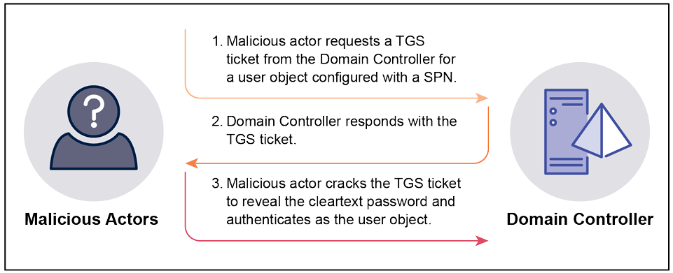
Figure 1. Overview of Kerberoasting Attack Workflow

Mitigating Kerberoasting
Kerberoasting mimics normal Active Directory functionalities and is a viable technique in any Active Directory environment hat has user objects that are configured with SPNs.
Therefore, the following security controls should be implemented to mitigate Kerberoasting:
- Minimize the number of user objects configured with SPNs. This reduces the attack surface for malicious actors to execute Kerberoasting.
- Create user objects with SPNs as group Managed Service Accounts (gMSAs). gMSAs have automatic password rotation, a 120-character password and simplified SPN management. These security features protect the password from being cracked, reducing the likelihood of successful Kerberoasting; however, if creating user objects with SPNs as gMSAs is not feasible, for example, it is a non-Windows-based system hosting the services, or the application does not fully support the use of gMSAs, such as Microsoft’s System Center Configuration Manager (SCCM), set a minimum 30-character password that is unique, unpredictable, and managed.
- Assign user objects with SPNs the minimum privileges necessary to perform their functions and make sure they are not members of highly privileged security groups, such as the Domain Admins security group. If malicious actors successfully execute Kerberoasting and crack the TGS ticket to reveal the plaintext password, then minimizing the privileges assigned to the user object will reduce the impact and limit the access gained by the adversary.

Detecting Kerberoasting Attacks
Detecting Kerberoasting attacks can be difficult as this technique mirrors legitimate Active Directory administrative and non-administrative activities. User objects request TGS tickets daily when accessing services in the domain, and the events that are generated for these legitimate activities are the same events that are generaged by Kerberoasting attack attempts. This makes it possible for Kerberoasting to be missed amongst the numerous legitimate events that are recorded and logged. One method to detect Kerberoasting is to analyze TGS ticket request events (Event ID 4769) and identify instances where TGS requests are made for multiple user objects that are configured with SPNs within a short timeframe. Kerberoasting typically involves retrieving TGS tickets for all user objects with SPNs simultaneously. The presence of TGS ticket request events (Event ID 4769) for numerous user objects with SPNs in a brief period may indicate that Kerberoasting is occurring or has occurred. Another method for detecting Kerberoasting is to analyze unusual TGS ticketing requests for services. For instance, this could include TGS request for services that are not typically associated with or accessed by the requesting user or computer object, such as a backup server that is usually only accessed by other servers.
The events in Table 1 should be centrally logged and analyzed in a timely manner to promptly identify Kerberoasting activities.
Table 1. Events That Detect Kerberoasting Activities
Event ID | Source | Description
4738, 5136 | Domain Controllers | These events are generated when a user account is changed. Malicious actors can modify user objects and add a SPN so they can retrieve their Kerberos service ticket. Once the Kerberos service ticket has been retrieved, the user object is modified again and the SPN removed.
4769 | Domain Controllers | This event is generated with a TGS ticket is requested. When adversaries execute Kerberoasting, Event ID 4769 is generated for each TGS ticket that is requested for a user object.  Malicious actors commonly try to retrieve TGS tickets with Rivest Cipher 4 (RC4) encryption as these tickets are easier to crack to reveal their plaintext password. If a TGS is requested with RC4 encryption, then the Ticket Encryption type contains the value 0x17 for Event ID 4769. As this type of encryption is less frequently used, there should be fewer instances of Event ID 4769 tied to RC4 encryption, making it easier to identify potential Kerberoasting activity.  Common offensive security tools used by both malicious actors and security professionals to perform Kerberoasting will set the Ticket Options value to ‘0x40800000’ or ‘0x40810000.’ These values determine the capabilities of the TGS ticket and how it can be used by malicious actors. As these Ticket Options values are commonly used by offensive security tools to perform Kerberoasting, they can be used to identify Kerberoasting activities as well.

This technique can be detected with the assistance of Active Directory canaries.
Attack #2: Authentication Server Response (AS-REP) Roasting
AS-REP Roasting exploits Active Directory user objects that are configured to not require Kerberos pre-authentication. Like Kerberoasting, any user object in the domain, including unprivileged user objects, can send an Authentication Server Request (AS-REP) to retrieve the AS-REP ticket for any user object that is configured to not require Kerberos pre-authentication. The AS-REP ticket is encrypted with the user object’s password hash, which can be cracked offline to reveal its plaintext password. If malicious actors crack the AS-REP ticket and successfully obtain the plaintext password, they can then authenticate themselves against the domain as that user object (see Figure 2 below).
AS-REP Roasting may be executed by adversaries shortly after they gain initial access to an Active Directory domain to escalate their privileges and move laterally within.
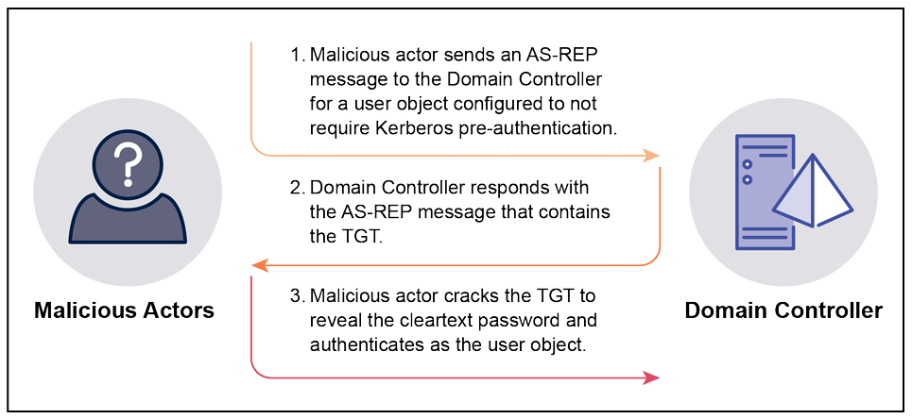
Figure 2. Overview of AS-REP Roasting Attack Workflow
Mitigating AS-REP Roasting Attacks
Adversaries have fewer opportunities to perform AS-REP Roasting than Kerberoasting attacks, as user objects are configured by default in AD DS to require Kerberos pre-authentication, and AS-REP Roasting is only possible if user objects are configured to not require the option to have Kerberos pre-authentication performed. The Kerberos authentication protocol, introduced in Kerberos version 5, is the sole authenticating protocol that is used by Active Directory. The configuration to not require Kerberos pre-authentication only exists to support systems that do not support Kerberos which are typically considered legacy IT and are less common. If defenders and organizations have applications and systems that use a version of Kerberos earlier than version 5, then they may configure user objects not to require Kerberos pre-authentication, leaving the entire environment vulnerable to AS-REP Roasting attacks.
The following security controls should be implemented to mitigate AS-REP Roasting attacks:
- Ensure all user objects require Kerberos pre-authentication. AS-REP Roasting can be mitigated if all user objects require Kerberos pre-authentication; however, if user objects must be configured to bypass Kerberos pre-authentication, then these user objects should be granted the minimum set of privileges required for them to perform their functions and should not be members of highly privileged security groups, such as Domain Admins. Additionally, set a minimum 30-character password for service accounts or a minimum 15-character password for users, and ensure the password is unique, unpredictable, and managed.

Detecting AS-REP Roasting Attacks
If applications or systems are using a version of Kerberos prior to version 5, then AS-REP Roasting attacks will mirror legitimate Active Directory activities, including triggering the same events to be written to security logs, and may also be difficult to detect given that they blend in to ‘background noise.’ AS-REP Roasting typically involves simultaneously retrieving TGT tickets for all users that are configured to bypass Kerberos pre-authentication. As such, one method to detect AS-REP Roasting (similar to a method to detect Kerberoasting) is to analyze TGT request events, specifically Event ID 4768, and identify instances where TGT ticket requests are made for multiple user objects that have Kerberos pre-authentication disabled within a short timeframe.
The events in Table 2 below should be centrally logged and analyzed in a timely manner to identify AS-REP Roasting attack activities.
Table 2. Events that Detect AS-REP Roasting Attack Activities
Event ID | Source | Description
4625 | Domain Controllers | This event is generated when an account fails to log on to the domain correctly. AS-REP Roasting can be executed prior to authentication, meaning adversaires only need to be connected to the domain without needing a valid user object. The AS-REP ticket is still retrieved, but Event ID 4625 is generated as no valid credentials were provided when requesting the ticket. If AS-REP Roasting is executed in the context of a valid user object, then the AS-REP ticket is retrieved, valid credentials are provided and Event ID 4625 is not generated. Event ID 4625 can be correlated with Event ID 4768 to confirm if AS-REP Roasting was executed in the context of a valid domain user object.
4738, 5136 | Domain Controllers | These events are generated when a user account changes. Adversaries can modify user objects and configure them to not require Kerberos pre-authentication as a technique to retrieve their AS-REP ticket. Once the AS-REP ticket service ticket has been retrieved, the user object is modified again to require Kerberos pre-authentication. If these events are generated for changes to the Kerberos pre-authentication, it may indicate AS-REP Roasting is occurring, or has occurred.
4768 | Domain Controllers | This event is generated with a TGT is requested. Adversaries executing AS-REP Roasting attacks trigger this event as the AS-REP message that is returned from a Domain Controller contains a TGT. If this event is triggered multiple times in a short timeframe, it may indicated AS-REP Roasting is occurring, or has occurred.  Adversaries will commonly try to retrieve TGT tickets with Rivest Cipher 4 (RC4) encryption as these TGT tickets are easier to crack to reveal their plaintext password. If a TGT is requested with RC4 encryption, then the Ticket Encryption type will contain the value 0x17 for Event ID 4769. As this encryption type is less frequently used, there should be fewer instances of Event ID 4769 with this encryption type, making it easier to identify potential AS-REP Roasting attacks on the domain.

This type of compromise can also be detected with the assistance of Active Directory canaries.

Attack #3 – Password Spraying
Password spraying attempts to authenticate multiple user object using either a single password or multiple passwords until they successfully authenticate to a user object. These passwords can come from public password wordlists or be derived from the targeted environment for a higher likelihood of success. For example, adversaries may identify passwords being reused in the target environment and use these in password spraying to identify if they belong to any user objects. To minimize authentication attempts and the risk of detection, adversaries can retrieve a list of usernames from Active Directory and attempt to authenticate to each one using a single password. This technique is particularly effective against organizations that reuse passwords, and don’t specify password complexity as rule enforcement. If adversaries compromise a user object via password spraying, then they control that user object and inherit that user object’ s same access and privileges.
Note on File Shares and Active Directory Credentials
Many security agencies have actively observed malicious actors scanning file shares as part of their efforts to locate insecurely stored secrets, such as credentials for Active Directory user objects. Multiple tools, such as SMBMap and Snaffler, can identify file shares and scan them for credentials (including plaintext passwords), sensitive information, Application Programming Interface (API) keys, digital certificates, standalone password managers, and backups. These tools are commonly used after gaining initial access to an Active Directory domain to try and locate credentials for privileged user objects.

If malicious actors locate credentials, they are likely to use them to escalate their privileges and move laterally within the domain. This reduces the likelihood of detecting malicious actors, as they are able to gain control of other user objects without having to attempt riskier techniques, such as Kerberoasting and Password Spraying.

To reduce the likelihood of adversaries locating credentials in file shares and using them in password spraying attacks, defenders and organizations should use an enterprise-grade password management solutions (where possible, and where feasible) to secure store their sensitive information, including credentials for Active Directory user objects.

Additionally, defenders and organization should periodically conduct their own internal scans to identify any sensitive information leakage or that is insecurely stored on file servers within the domain network.

dfdfdf

